# NSW Fire Ant Program – Schools information

*August 2024*

## Background

On 24 November 2023, fire ants (*Solenopsis invicta*), a prohibited matter species under the NSW *Biosecurity Act 2015*, was first detected in South Murwillumbah. A second detection was confirmed on 19 January 2024 in Wardell.

Swift response measures have destroyed the fire ant populations found in NSW, with no new infested sites identified. The NSW Fire Ant team is now working closely with the National Fire Ant Eradication Program to prevent fire ants from re-entering NSW.

Vigilance among the NSW community, particularly in the north, is now crucial as human activity remains the primary driver of fire ant spread. Schools have a huge role to play with many eyes on the lookout for fire ants in the playground, at home and in public spaces.

We all have a role to play. Biosecurity is a shared responsibility.

Below are some teaching resources, printable materials (in folders), and links to raise awareness among students and staff. For more information or enquiries, please contact:

**Tommy Wainwright -** *Communications and Engagement Officer*Phone: 0484 575 604 | Email: [tommy.wainwright@dpi.nsw.gov.au.](mailto:tommy.wainwright@dpi.nsw.gov.au)

## Primary resources

* Main page: [NSW DPI Schools Program – Investigate: fire ants (Stage 3)](https://www.nswdpi-schools-program.com/investigate-fireants)
* **Fire Ants_Investigate Fire Ants 2024**
* [Stage 3/4 Webinar](https://www.youtube.com/watch?v=KDc_nrp2dp8&t=1s)

## Secondary resources

* Main page: [NSW DPIRD Schools Program – Secondary](https://www.nswdpi-schools-program.com/fireants-secondary)
* Citizen Science Webinar HYPERLINK "https://www.nswdpi-schools-program.com/fireants-secondary" Secondary
* **FIRE ANTS Presentation 2024**
* **FIRE ANTS Worksheet 2024**
* **FIRE ANTS Worksheet 2024 Answers**

## More resources and contacts

A3 Students & staff posters

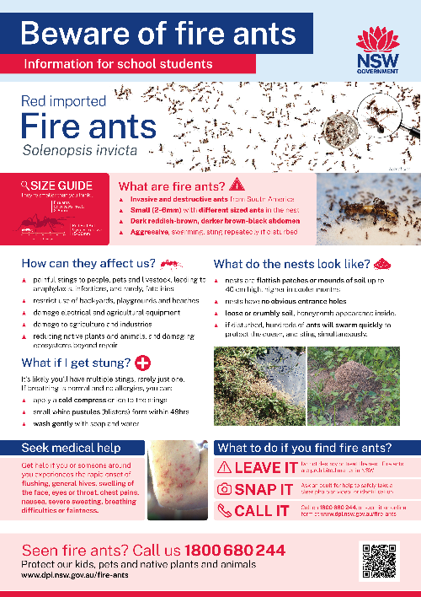 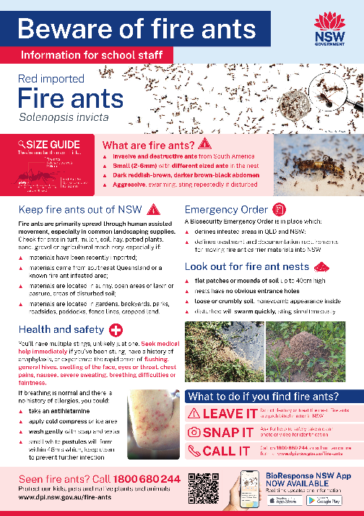

DL Flyer & communications graphic

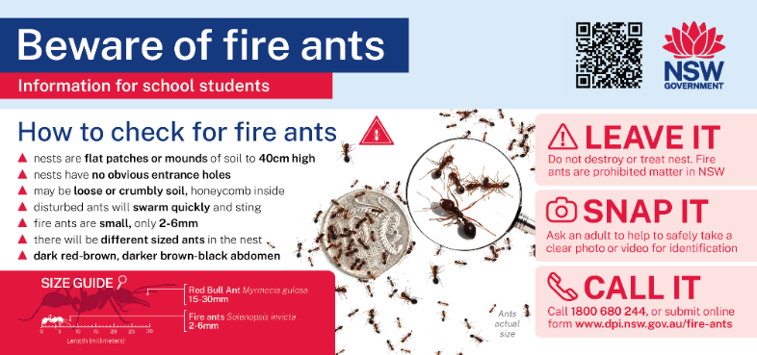

* **A3 Students poster** for printing/screen
* **A3 Staff poster** for printing/screen
* **DL flyer & communications graphic** for printing or digital
* General Resources:[www.dpi.nsw.gov.au/rifa-resources](http://www.dpi.nsw.gov.au/rifa-resources)
* For regular updates, sign up to the newsletter [here](https://www.dpi.nsw.gov.au/dpi/bfs/insect-pests/rifa/sign-up-for-updates).

For school administrators:

* **Asset Management Guide**
* **Procurement Guide**
* **Suppliers Guide**

## Newsletter content

Use the content below for school newsletter, daily notices or email content.

**Beware of fire ants in NSW**

NSW schools are urged to remain vigilant for fire ants (*Solenopsis invicta*), following detections at Murwillumbah and Wardell, northern NSW. One of the world’s most destructive invasive species, fire ants can have significant impacts for our health, lifestyle, environment, industries and economy.

Fire ants are present in areas of Southeast Queensland. While they do spread naturally, the highest risk for NSW is through the movement of fire ant carrier materials such as soil, mulch, turf, potted plants and machinery.

Students, parents and staff are urged to be vigilant for fire ants. If you suspect fire ants:

* **LEAVE IT:** Do not destroy or treat the nest. Fire ants are prohibited matter in NSW under the NSW Biosecurity Act 2015.  Only DPIRD can authorise treatment.
* **SNAP IT:** Safely take a clear photo or video for identification.
* **CALL IT:** Call the hotline on 1800 680 244, submit an online form.

Let’s keep working together to keep this pest out of NSW. For more information on fire ants, identification, nests and how we are managing the threat to NSW, visit: [www.dpi.nsw.gov.au/fire-ants](http://www.dpi.nsw.gov.au/fire-ants) or call 1800 680 244. 

Graphic for use in communications:

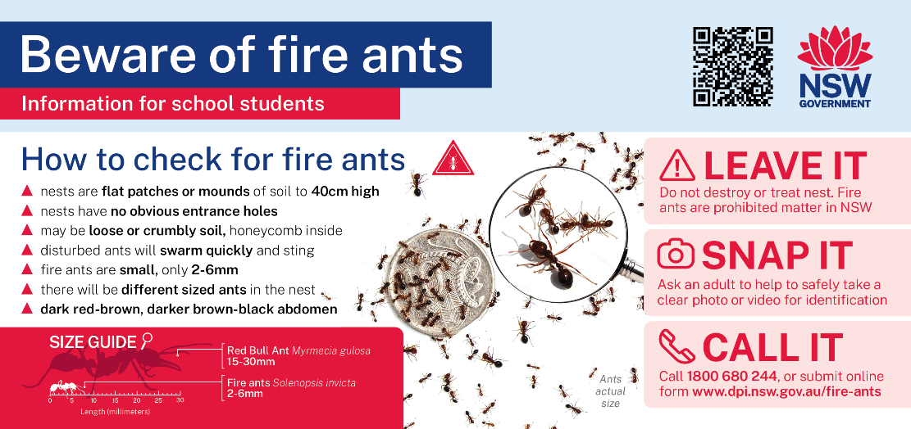

## The key messages for students and staff are:

Red Imported Fire Ants are one of the world’s worst invasive species. Up to 97% of Australia is suitable for fire ants and large-scale infestation could cost $1.65b per year, more than feral cats, wild dogs, foxes, camels, rabbits and cane toads combined.

If you suspect fire ants:

* **LEAVE IT:** Do not destroy or treat the nest. Fire ants are prohibited matter in NSW. Avoid disturbing or attempting to treat nests themselves to prevent injury and further spread.
* **SNAP IT:** Safely take a clear photo or video for identification.
* **CALL IT:** Call us on 1800 680 244, submit an online form. Residents and staff are reminded to report potential sightings promptly to the **NSW Biosecurity Hotline 1800 680 244** or on the website[www.dpi.nsw.gov.au/fire-ants](http://www.dpi.nsw.gov.au/fire-ants).

**Fire ants are not marching; they are being carried.** The spread of fire ants is driven primarily by human activity, predominantly the movement of materials used for landscaping, building, and agriculture, such as soil, turf, mulch, hay, potted plants, growing media and machinery.

Stay up to date with the latest [Biosecurity (fire ant) Emergency Order](https://www.nsw.gov.au/departments-and-agencies/department-of-regional-nsw/our-offices-agencies/department-of-primary-industries) and be aware of your obligations when moving fire ant carrier materials from *fire ant infested areas* in southeast Queensland and northern NSW, and the *fire ant movement control areas* at South Murwillumbah and Wardell.

Let’s keep working together to keep this pest out of NSW. For more information visit: [www.dpi.nsw.gov.au/fire-ants](http://www.dpi.nsw.gov.au/fire-ants) or call 1800 680 244.